**Acton University**

**Dangerous Devices: Do Our Devices Work for Us or Do We Work for Them?**

Rev. Dr. A. Trevor Sutton

august.sutton@cui.edu

atrevorsutton.com

**Illustration from Jonathan Swift, Gulliver’s Travels, part 1, chapter 2** | “We conjecture it is either some unknown animal, or the god that he worships; but we are more inclined to the latter opinion, because he assured us . . . that he seldom did anything without consulting it.”

**Time in Technopoly:** Everything bends to the logic of technology. Our devices shape our approach to time, time-management, and how best to use time.

* The 67 Hour Rule

**Thesis**: Despite these time-saving devices, we have less time than ever before.

1. We have lost the narrative when it comes to work, time, & devices
2. We need a path and a vision for “making the best use of the time” (Ephesians 5:16)

**Proposal**: Redeeming Time

1. Telos: Ultimate aim, goal, or destination
2. Intention: Directing time around a telos
3. Materials: Selecting tools and devices around a telos
4. Eternity: Timelessness, permanence, and vertical time

Example: Benedictine Orders

**Telos**: Efficiency is not the summum bonum (ultimate good) of life. Nor is productivity, output, or multitasking.

What is the ultimate aim of the work that you do?

What is the ultimate aim of your time and work?

* Vocation: Our lives are enmeshed in a world of God-given offices, neighbors, and work. Aim for enduring work that has eternal resonance.
  + Micah 6:8

**Intention**: Old French: entendre, "to direct one's attention" Latin: intendere, "turn one's attention, strain (in quest of something)” You cannot be intentional without an aim or a destination. Do your hours and days align with your ultimate aims?

* Practices, formative stories and virtues drive us toward a particular aim – whether we realize it or not.
  + Psalm 90:12

**Materials:** Before we can select which tools, devices, and technologies to use, we have to have a sense of our aim and intentions.

What if we choose tools not only on the basis of time-savings and efficiency, but

according to our ultimate aims?

Do you have criteria for adopting new technologies and tools for the work that you

do?

* “When somebody has used a computer to write work that is demonstrably better than Dante's, and when this better is demonstrably attributable to the use of a computer, then I will speak of computers with a more respectful tone of voice, though I still will not buy one.” (Wendell Berry)

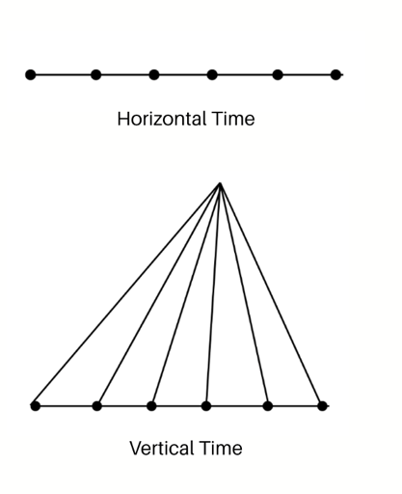**Eternity:** There are two ways that we can think of time: horizontally and vertically. *Horizontal time*—or ordinary time—deals in the temporal realm and moves in a linear, horizontal fashion. *Vertical time*rises above the ebb and flow of passing time and touches permanent things.

Do you usually approach time horizontally, vertically, or in some other way?

* “Good Friday 1998 is closer in some way to the original day of the Crucifixion than mid-summers day 1997. Once events are situated in relation to more than one kind of time, the issue of time-placing becomes quite transformed…The really real, full being is outside of time, unchanging.” (Charles Taylor)

**Four These on how to avoid Dangerous Devices:**

1. Don’t save time. Don’t kill time. Redeem time.
2. Order your time according to ultimate things.
3. Choose and use devices according to ultimate aims.
4. Customize, move, or force your devices to work for you.

**Ways to make your Devices Work for You:**

1. Set your phone to grayscale
2. Periodically fast from some devices.
3. Use tools that require skills, efforts, or abilities.
4. Ask: What problem is this device solving?